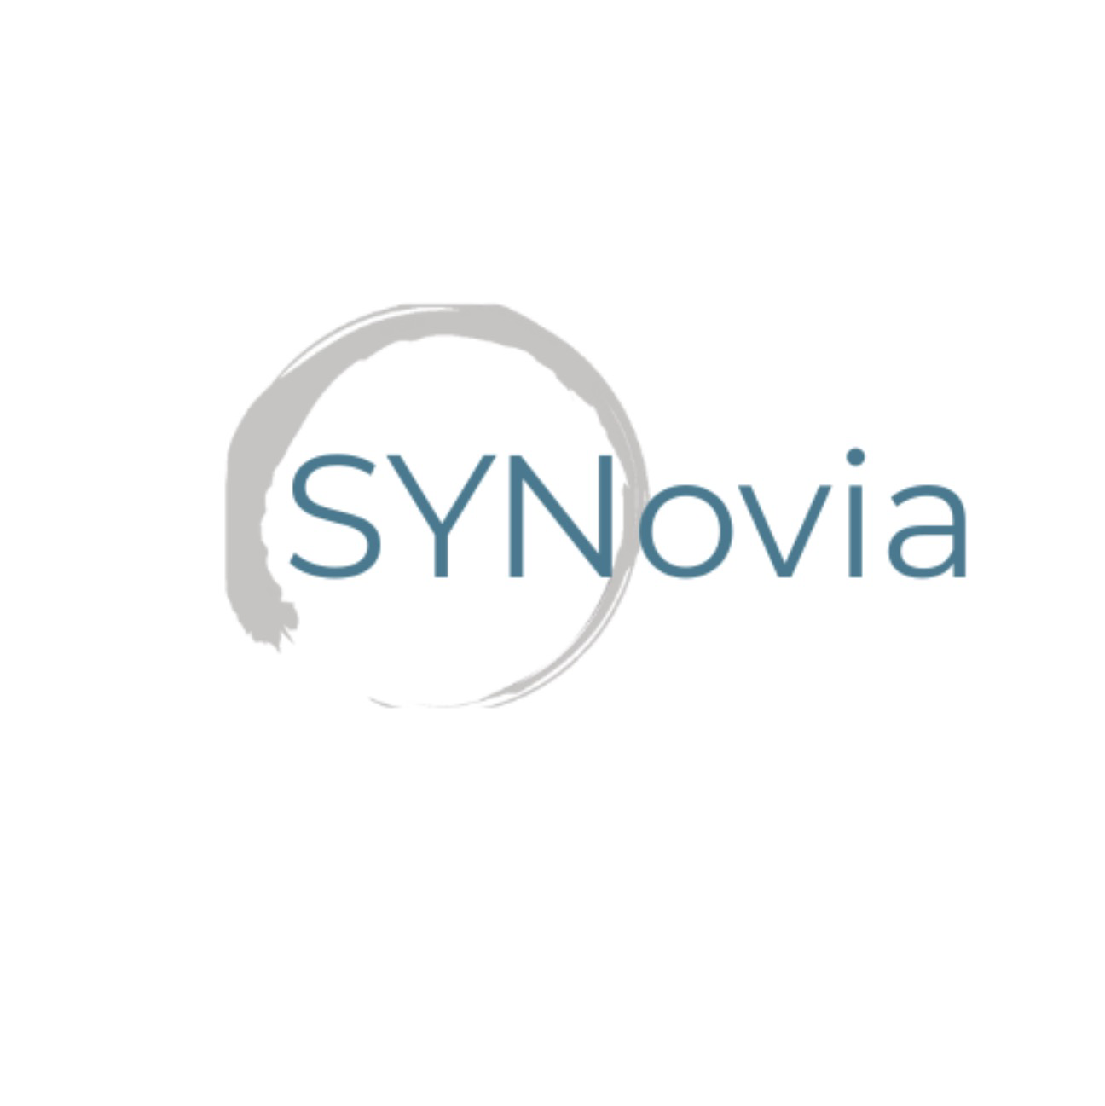
Privacy Statement: How We Use Your Health Records
(GDPR-Compliant Notice for High Peak Osteopath & Synovia)
Why We Collect Information About You
The clinicians caring for you keep records about your health, care, and treatment. These records help ensure you receive the highest quality care. Your records are stored securely as electronic records. Information we hold may include:
- Basic details about you (name, address, gender, email address, telephone number, date of birth)
- Details of contacts you have with us, such as clinic visits
- Notes and reports relating to your care and treatment
How Your Records Are Used
Your records are used to guide and deliver the care you receive. This ensures:
- All professionals involved have accurate, up-to-date information about your needs and future care requirements
- We have a sound basis for assessing the quality of care you receive
- We can work effectively with others involved in your care
- Any concerns you raise can be fully investigated
Your information may also be used anonymously (with all identifying details removed) to:
- Review and monitor the quality of care we provide
- Ensure our services meet the needs of patients
- Train and educate staff
In certain circumstances, identifiable information may be used for essential healthcare purposes such as auditing or research, but only where lawful and appropriate under GDPR.
We only use data provided by patients and clients for professional purposes and always in accordance with the General Data Protection Regulation (GDPR). All information is processed fairly, lawfully, and for specific purposes. Personal information is never shared with third parties unless you have given explicit consent or we are legally required to do so.
Secure Shared Record Keeping Between High Peak Osteopath and Synovia
All health records are held securely and may be accessed by both High Peak Osteopath and Synovia where this is necessary for your assessment or treatment. This shared access supports safe, effective care.

If you would prefer your records to be kept separate and not shared between the two services, this can be arranged. This option will be discussed with you at your initial appointment, and appropriate measures will be put in place according to your preference.
Your Confidentiality
Your confidentiality is protected by law. Records are stored securely, and only authorised personnel have access to them.
We take all reasonable steps to:
- Protect the confidentiality and security of your personal information
- Ensure your information is accurate and kept up to date where necessary
We operate a Records Retention, Destruction and Archiving Policy, ensuring your data is retained only as long as necessary for the purpose for which it was collected. Upon request, information can be corrected or erased where appropriate and lawful. Some records may need to be retained for a longer period for legal, regulatory, or audit purposes related to healthcare.
Disclosure of Your Personal Data
In the normal course of our operations, we may disclose your data (only where necessary) to third-party organisations supporting the delivery of our services, such as:
- Business partners, suppliers, or sub-contractors involved in delivering your care
- IT system support and secure hosting providers
- Secure data storage or exercise-programme software providers
- Confidential waste destruction companies
- Marketing service providers (only with your explicit consent)
All third-party processors operate under strict contractual obligations relating to confidentiality, security, and compliance with Data Protection Law.
Access to Your Health Records
Under the GDPR and the Freedom of Information Act, you have the right to request access to the information we hold about you. You may also request corrections to your records where necessary.

